CHAPTER 1. Information Representation

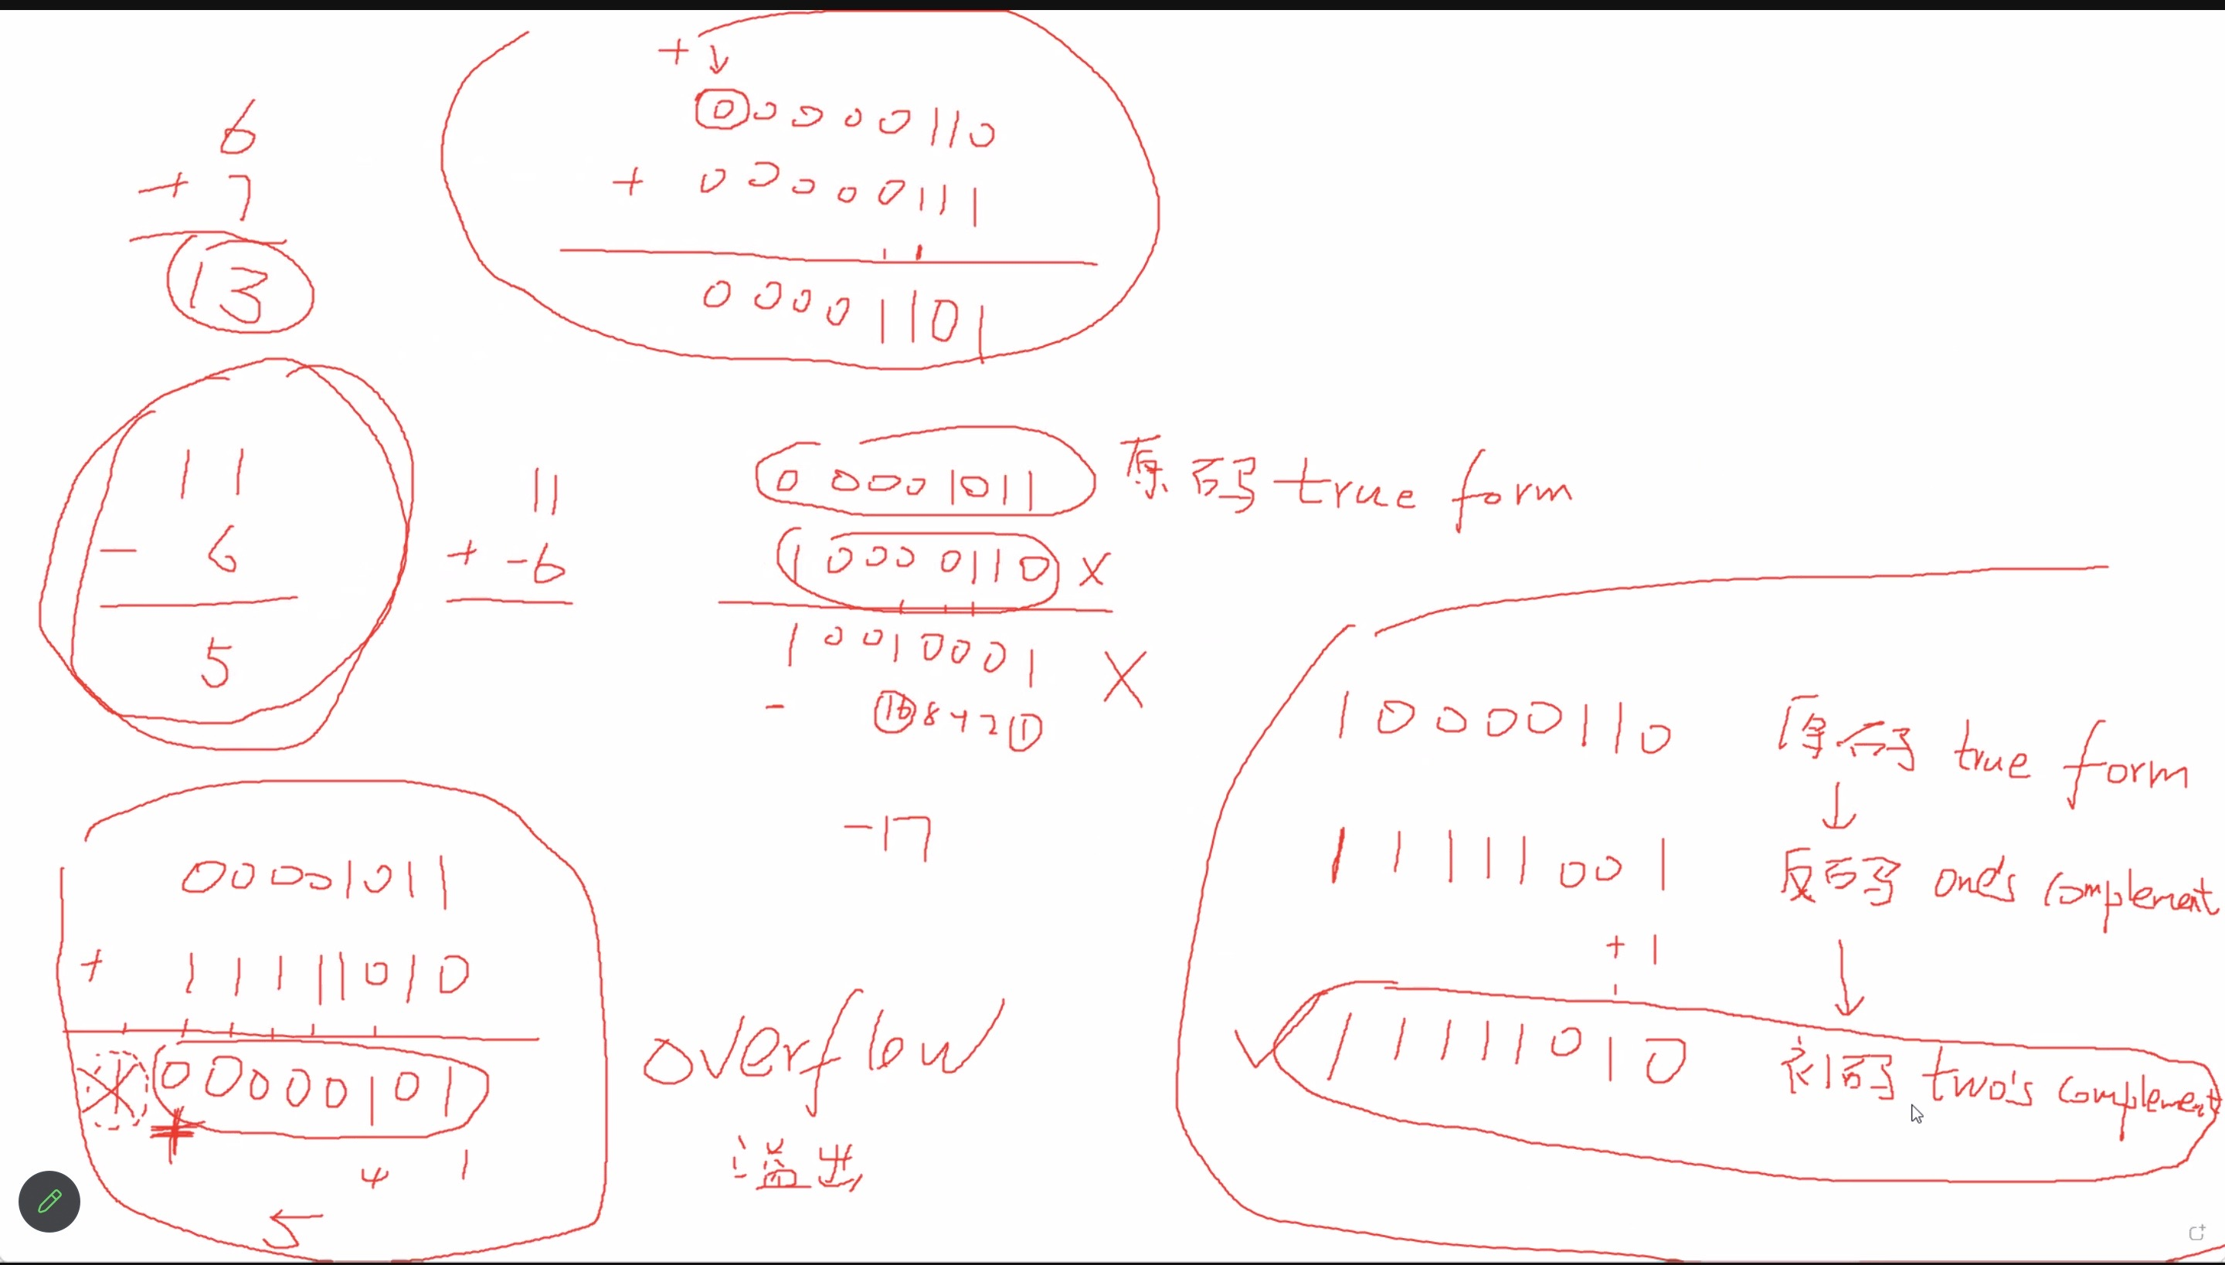

Picture element (pixel): the smallest identifiable component of a bitmap image

Colour depth: the number of bits used to represent one pixel

BITMAP:LARGE FILE SIZE

MADE OF PIXELS

ENLARGE WITH PIXELLATION

SVG: SMALL FILE SIZE

MADE OF INSTRUCTIONS

ENLARGE WITHOUT PIXELLATION

BCD:ONE DENARY DIGIT EACH 4 DIGITS OF BCD

RESULT:--Vector graphic: a graphic consisting of drawing objects defined in a drawing list

SINGAL OBJECT CODE --Drawing object: a component defined by geometric formula and associated properties

OBJECTS CODE COLLECTION--Drawing list: contains one set of values for each drawing object

SI UNITS

|  |  |
| --- | --- |
| NAME | BYTES |
| 1 kilobyte (1 KB) | 1 000 |
| 1 megabyte (1 MB) | 1 000 000 |
| 1 gigabyte (1 GB) | 1 000 000 000 |
| 1 terabyte (1 TB) | 1 000 000 000 000 |
| 1 petabyte (1 PB) | 1 000 000 000 000 000 |

IEC UNITS

|  |  |  |
| --- | --- | --- |
| NAME | NUMBER OF BYTES | EQUIVALENT VALUE |
| 1 kibibyte (1 KiB) | 21O | 1 024 |
| 1 mebibyte (1 MiB) | 220 | 1 048 576 |
| 1 gibibyte (1 GiB) | 230 | 1 073 741 824 |
| 1 tebibyte (1 TiB) | 240 | 1 099 511 627 776 |
| 1 pebibyte (1 PiB) | 250 | 1 125 899 906 842 624 |

SOUND:

Sampling resolution: the number of bits used to store each sample

Sampling rate: the number of samples taken per second

ASCII only support english

Fixed length encoding, each character use 8 bits

only several bits are used, only 2^7=128 characters

Extended ASCII

Fixed length encoding, each character use 8 bits

all 8 bits are used, support 2^8=256 characters

Unicode 万国码 e.g. UTF-8

ASCII is subset of Unicode

Variable length coding, support many languages

Lossless compression---could restore to original file---RLE(Run-Length Encoding)

Lossy compression---couldn't restore to original file